
  - JIG Inventory Management System

Project Overview

(example only)

Overview
Current warehouse operations at Global Logistics Co. rely on manual spreadsheet entries, leading to a 12% discrepancy in year-end audits and frequent stockouts of high-demand items. Project SwiftStock is an automated Inventory Management System (IMS) designed to digitize real-time stock movement and centralize supplier communication.

The Solution
SwiftStock leverages IoT barcode integration and an automated reorder engine to eliminate manual entry errors. By transitioning to a centralized database, the system provides a "single source of truth" accessible across the warehouse, sales, and procurement departments.

Key Capabilities
- Real-Time Tracking: Instant updates on stock levels via mobile barcode scanning.
- Automated Procurement: Predictive logic that generates purchase orders when stock hits safety levels.
- Advanced Analytics: Monthly reports on turnover rates and "dead stock" identification.
- Role-Based Security: Tiered access to ensure data integrity and financial privacy.

Technical Documentation

Flow Chart
[insert flowchart here]

Tech Stack
This is the "gold standard" for large-scale warehouses where data integrity and complex relationships are the top priority.
- Frontend: Angular (built-in features for large-scale enterprise apps).
- Backend: Java with Spring Boot (extremely stable and secure).
- Database: PostgreSQL or Oracle (Relational databases are best for strict inventory counting).
- State Management: Redux (to keep track of stock levels across multiple screens).
- Best for: Large corporations, high-security environments, and complex reporting.

System Architecture
The system follows a Client-Server architecture using a MERN stack (MongoDB, Express, React, Node.js).
- Frontend: React.js SPA (Single Page Application) for the user dashboard.
- Backend: Node.js environment running an Express server to handle RESTful API requests.
- Database: MongoDB Atlas (NoSQL) for flexible product schema and high-speed retrieval.
- Authentication: JSON Web Tokens (JWT) for secure session management.

Database Schema
The system utilizes four primary collections. Below is the structure for the Product and Transaction models:
Product Model: | Field | Type | Description | | :--- | :--- | :--- |

Installation and Deployment

User Manual

User Roles & Permissions
Who can view stock vs. who can delete records (Admin, Manager, Staff).

Getting Started
How to log in and navigate the dashboard.

Common Tasks
"How to add a new SKU," "How to generate a monthly report."

Data Backup & Security
How the data is saved and kept safe.

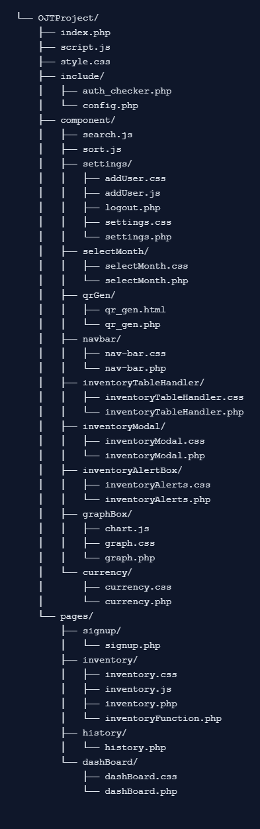

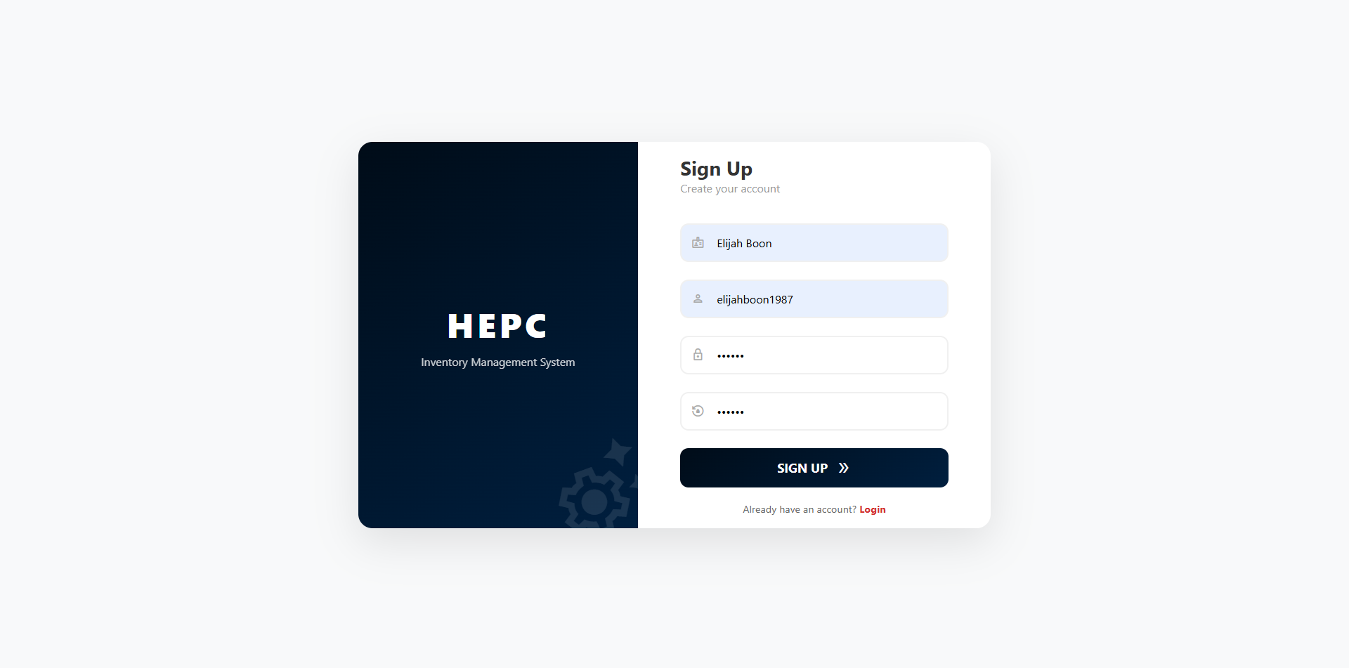
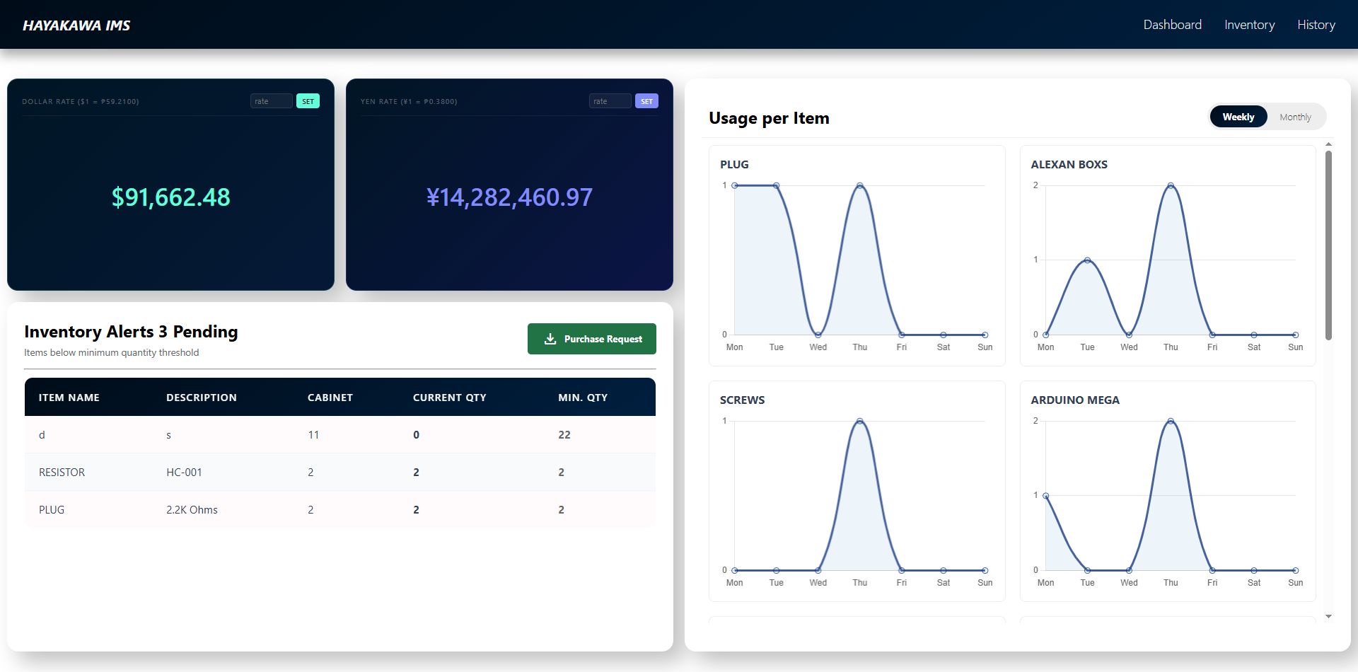

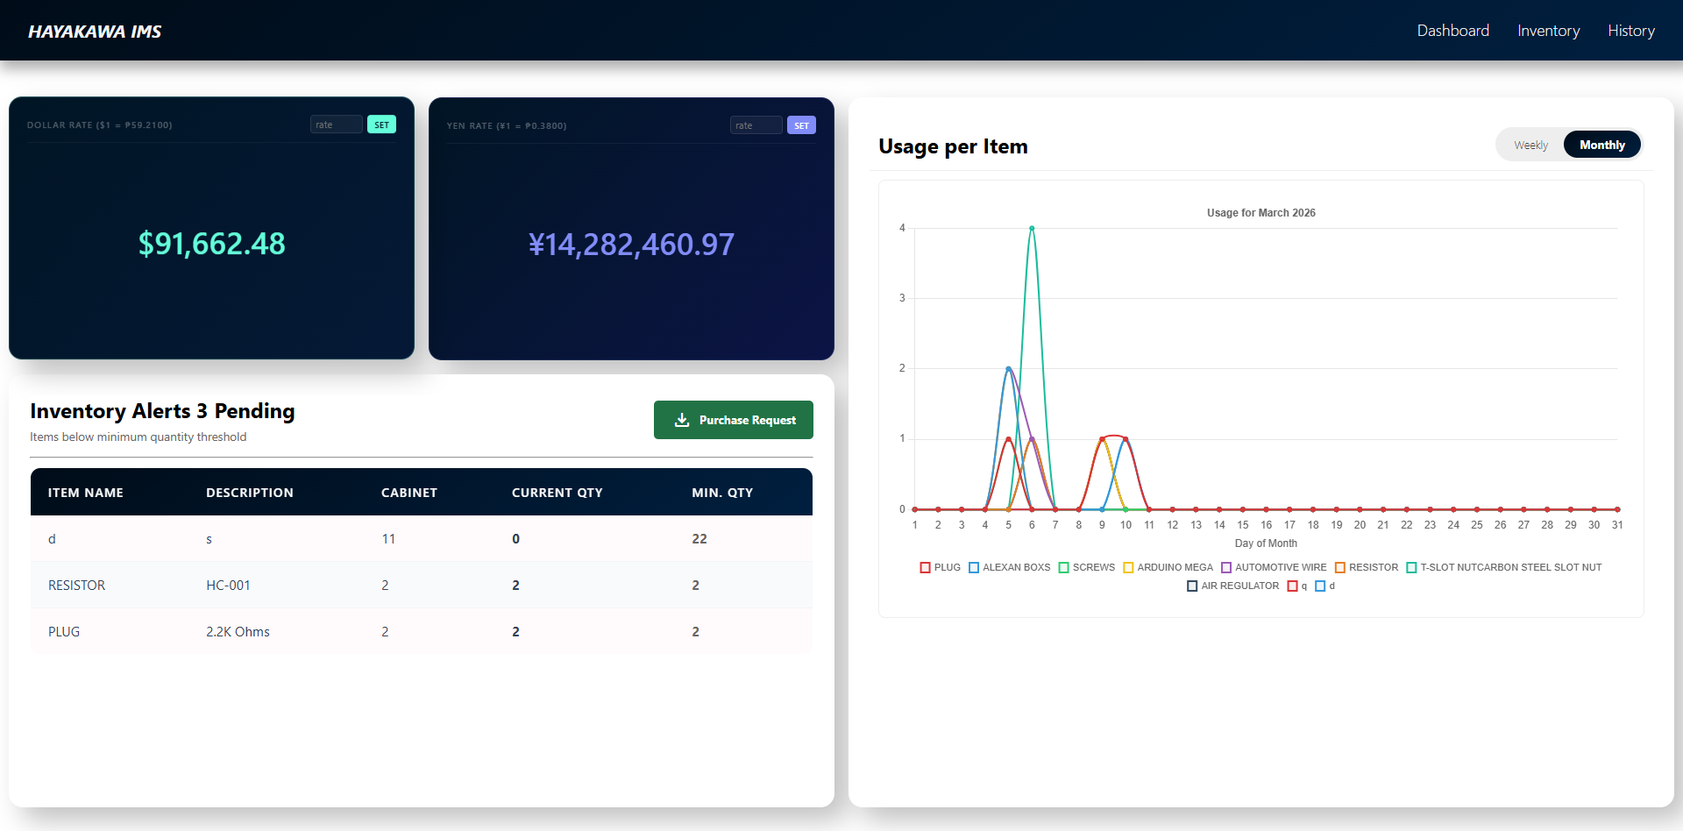
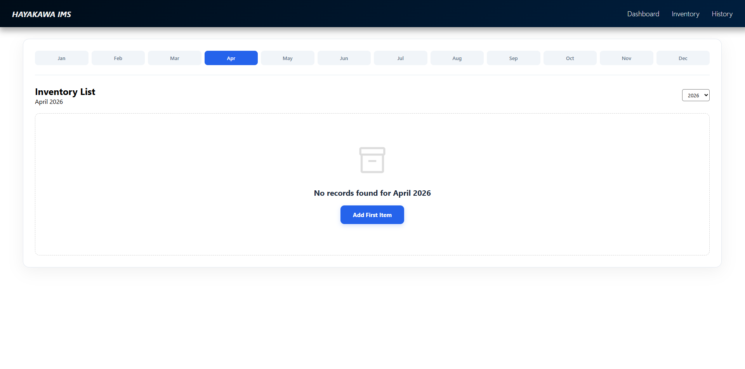
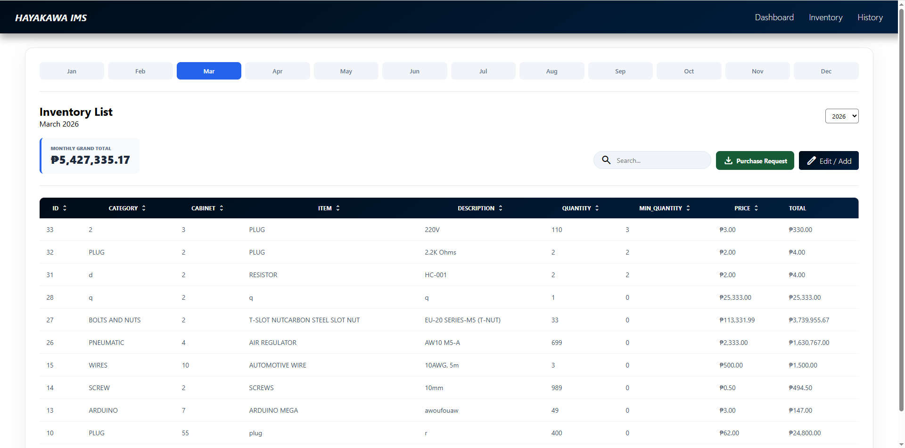

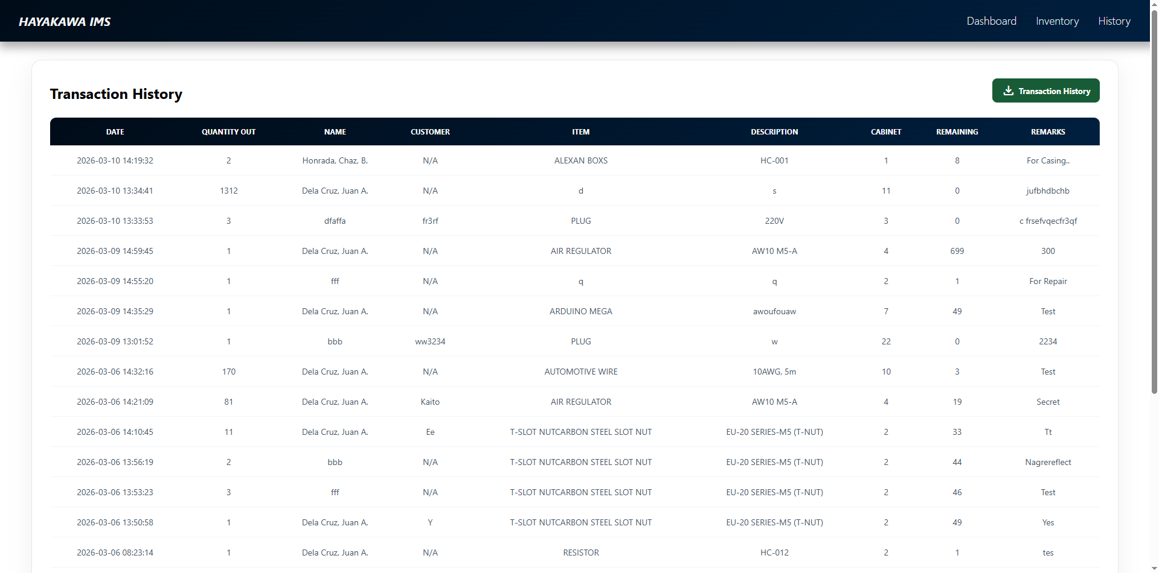

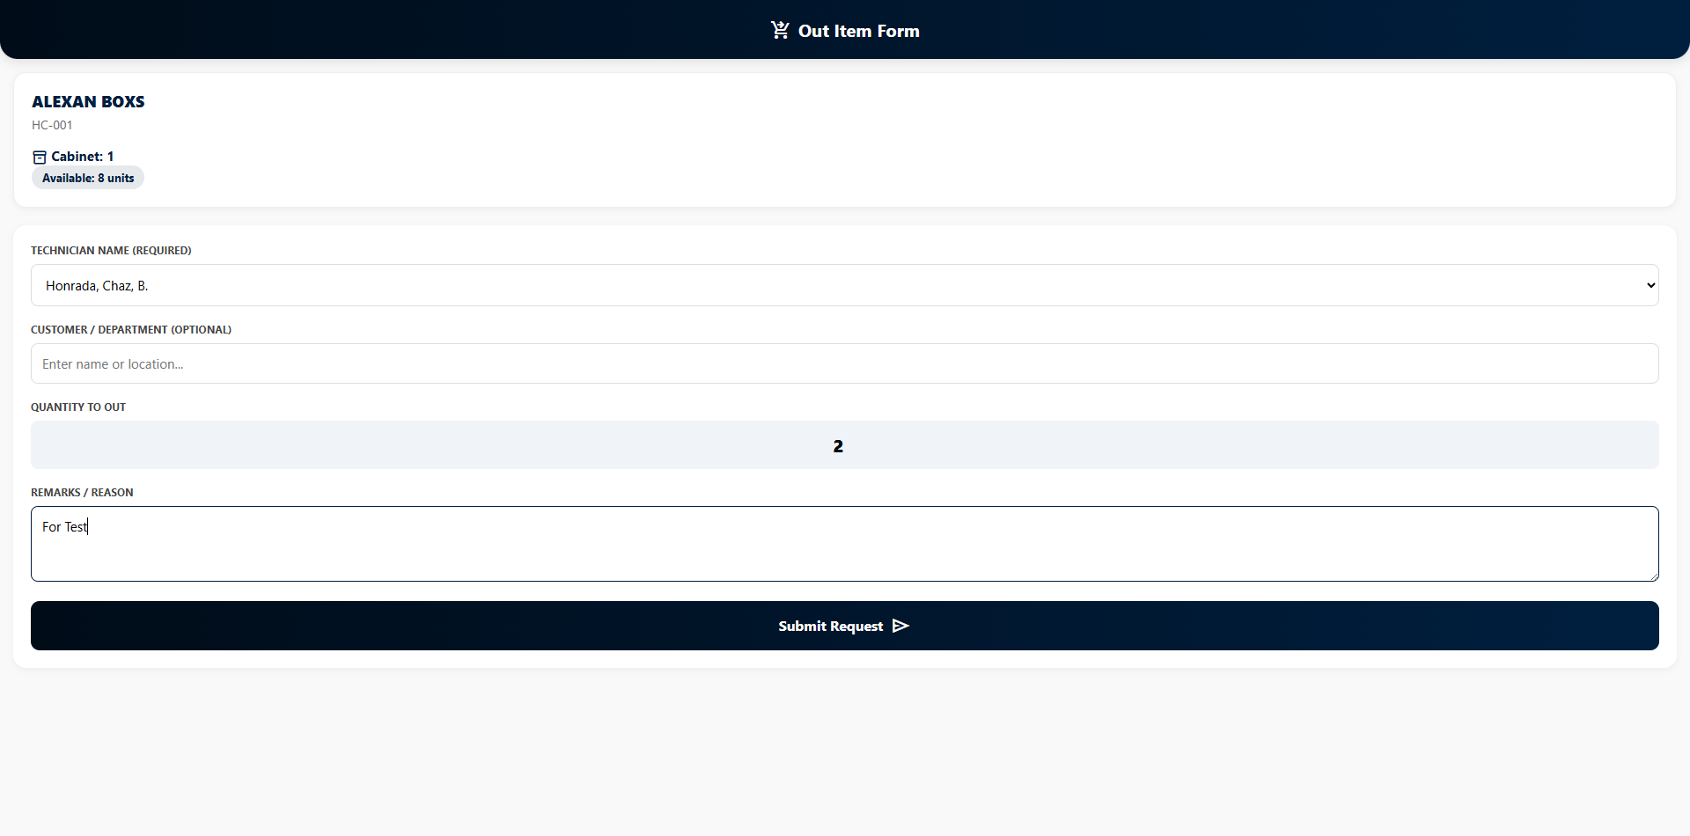

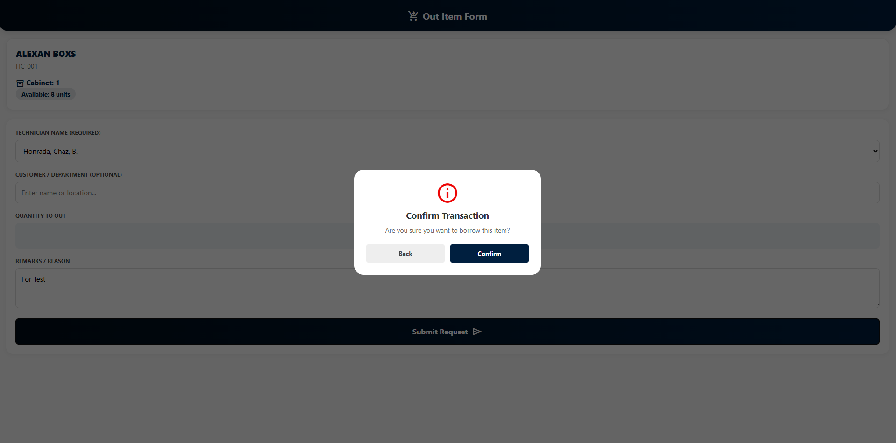

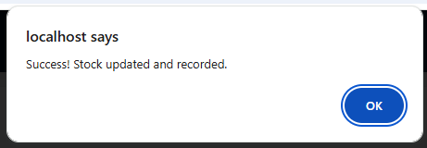

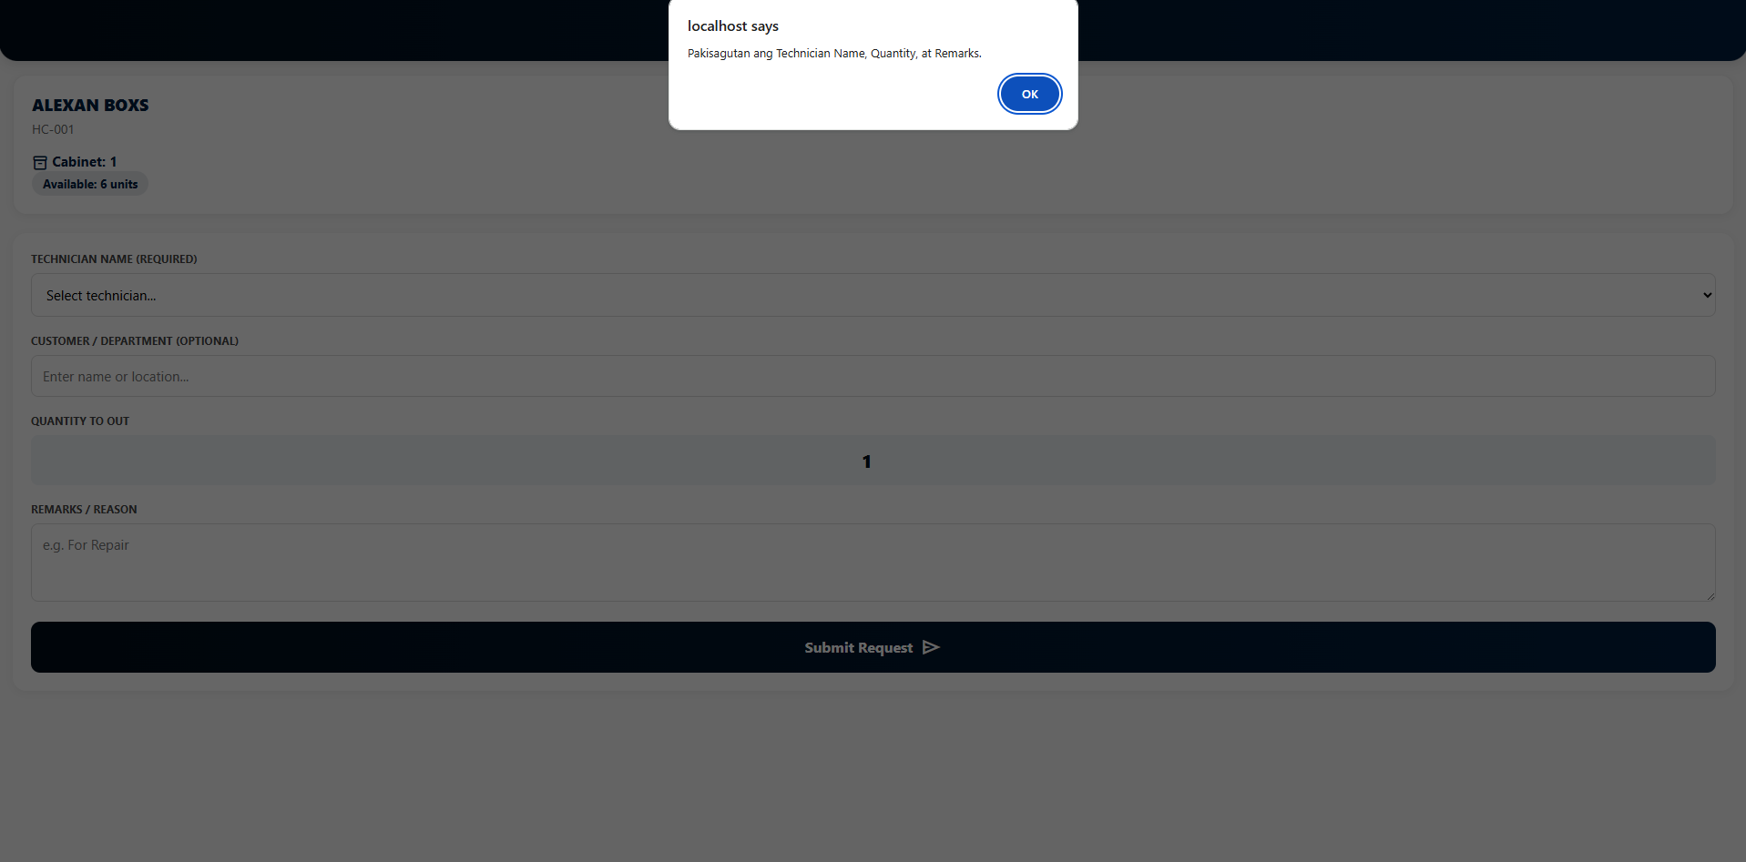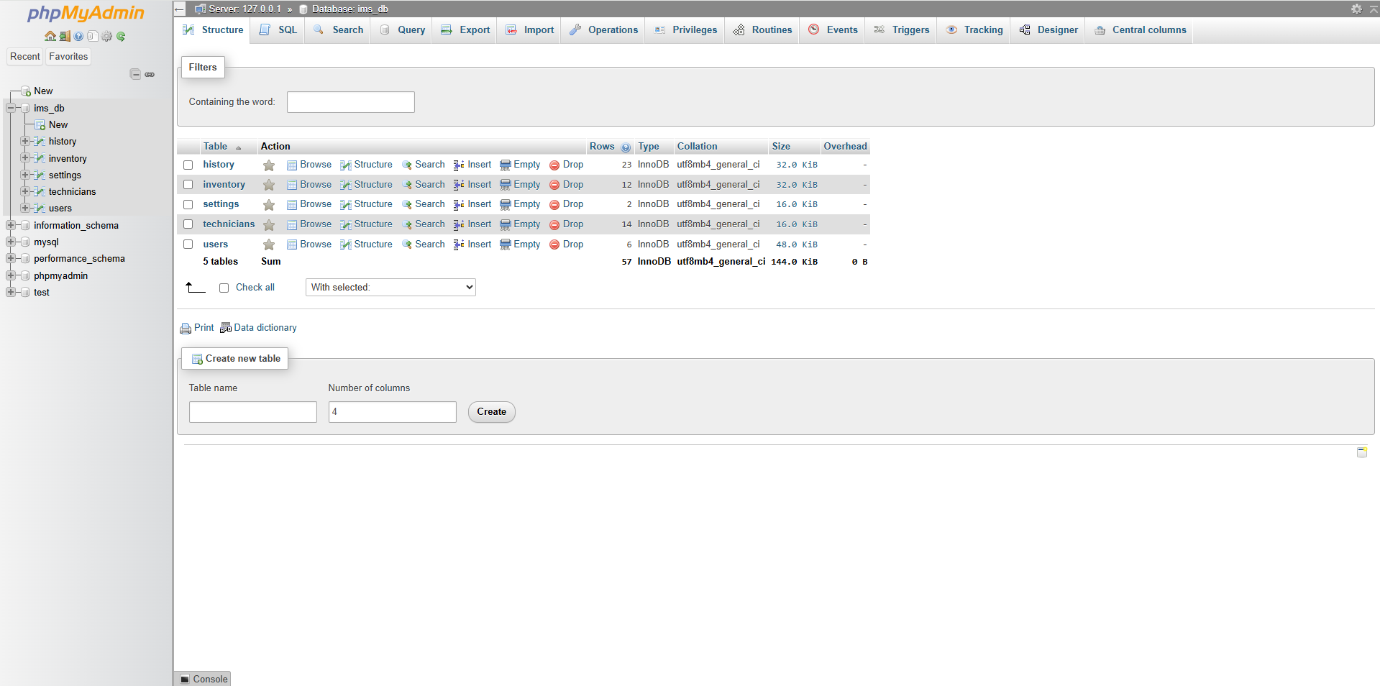

Appendix

1. Project Overview & Scope
This section sets the stage. It’s for stakeholders to understand the "why" and the "what."
- Executive Summary: A high-level brief of what the system does.
- Objectives: (e.g., "Reduce stockouts by 20%" or "Automate reorder points").
- Tech Stack: The languages, databases (like PostgreSQL or MongoDB), and frameworks used.
- Key Features: A bulleted list of core functionalities (Barcode scanning, reporting, etc.).

2. Technical Documentation
This is for the developers. It explains the "engine" under the hood.
- System Architecture: A diagram or description of how the frontend, backend, and database interact.
- Database Schema: Definitions of tables (Products, Suppliers, Transactions, Users) and their relationships.
- API Documentation: If the system connects to other tools, list the endpoints and request/response formats.
- Installation Guide: Step-by-step instructions on how to set up the environment and run the code.

3. Functional Requirements & Logic
This is the most critical part—it defines the "rules" of your inventory.
- User Roles & Permissions: Who can view stock vs. who can delete records (Admin, Manager, Staff).
- Inventory Logic: * Valuation Method: Are you using FIFO (First-In, First-Out), LIFO, or Weighted Average?
  - Reorder Logic: The mathematical formula used to trigger alerts.
For example, a simple reorder point $R$ can be calculated as:
$$R = (d \times L) + s$$
Where $d$ is average daily usage, $L$ is lead time, and $s$ is safety stock.
- Workflow Diagrams: Flowcharts showing how an item moves from "Received" to "Sold."

4. User Manual & Maintenance
This is for the daily users (the warehouse team).
- Getting Started: How to log in and navigate the dashboard.
- Common Tasks: "How to add a new SKU," "How to generate a monthly report."
- Troubleshooting: A FAQ for common errors (e.g., "Duplicate SKU detected").
- Data Backup & Security: How the data is saved and kept safe.

